Audit Location | AGRUMI-GEL SRL  Via Provinciale Centineo-Portosalvo, Contrada Girotta, Barcellona Pozzo di Gotto , ME, Italy | Date of Audit | Semiannounced audit
Audit I.D. | Periodical Audit (P2) | Client No. | PRJC-195219-2009-CSR-ITA_MSC /10416473
Management Rep. | Loredana De Francesco | E-mail | agrumigel@agrumigel.it  +39 090 9707329
Lead Auditor | Maurizio Santoro  Cell.: +39 3339669100 | Team Auditor(s)¹ | Maurizio Santoro (LA)
Scope | Citrus fruit processing for the production of : NFC Juices, concentrated juices, clear juices, semiclear juices, essential oils, pulp and cells, dried peel.
NACE/EA Sector | 15.50/03
Shift pattern | Central; 1-2 shift
Key Audit Objectives | - Determination of the conformity of the management system with the standard  - Evaluation of the effectiveness of the management system to ensure the organisation is capable to:  - Meet applicable statutory, regulatory and contractual requirements, and  - Achieve specified objectives
Focus Areas

AUDIT TEAM PRESENTATION
The Audit Team is formed by 1 auditor:
Lead Auditor: Maurizio Santoro, DNV employee since February 2004. He is qualified as Lead Auditor in the following schemes: ISO 9001, ISO 37001, SMETA, TAPA FSR/TSR, PdR 125:2022, ISO 30415. Lead Auditor SA8000 since 2005.
He is Scheme Responsible for CRMS and EASI.

Data: 1st Day
Time | Activity | Shift | Auditor/Auditee
09.00 | Opening Meeting with Senior Management to explain the scope of the audit and method of performance/reporting including confirmation of Focus Areas to be adopted. Statements on bribery policy, confidentiality and impartiality. | Central | LA/Management, SPT members
09.30 | Site tour  Working conditions tour | Central | LA/H&S Resp.le, SPT members

Data: 1st Day
Time | Activity | Shift | Auditor/Auditee
11.00 | In situ workers and Employees interviews and selection of production records  Total No. 4 people to be interviewed as a minimum (plus RSU/RLS):  Groups Interview: 1 groups of 2 workers  Individual Interview: 2 workers | 1^ | LA/Workers’ representative
12.00 | Workers’ Representatives interviews  SA8000 Workers’ representative, H&S Workers representatives, Unions’ representatives | 1^ | LA/Workers’ representative
13.00 | Lunch |  | LA
14.00 | Health & Safety & Working Conditions  - Control of Documents and Records  - Hazard identification, risk assessment and determining controls  - Legal and other requirements  - HSEQ program  - Emergency preparedness and response  - Evaluation of compliance  - Incident investigation | Central | LA/H&S Responsible, Workers’ representative
16.00 | Preparation of Audit Report by the audit team. |  | LA
17.00 | 1st Day Closing Meeting with Senior Management to present a summary of the findings and recommendations and to agree corrective action timescales (if applicable). |  | LA/Management, SPT members

Data: 2nd Day
Time | Activity | Shift | Auditor/Auditee
09.00 | Opening Meeting with Senior Management to explain the scope of the audit and method of performance/reporting including confirmation of Focus Areas to be adopted. Statements on bribery policy, confidentiality and impartiality. | Central | LA/Management, SPT members
09.30 | SPT member’s interview | Central | LA/ SPT members
10.00 | Stakeholder interview | Central | LA
10.30 | Review of Recordings and documents  Child and Young Labour, Forced and Compulsory Labour, Discrimination, Freedom of Association & Right to Collective Bargaining.  Document & Record Review, Working Hours, Payroll, Living Wage & Cost Accounting  At least 3 payrolls (2 for the single interviewed; other 1 randomly chosen) | Central | LA/SPT Members, HR officer
13.00 | Lunch

Data: 2nd Day
Time | Activity | Shift | Auditor/Auditee
14.00 | Management Representative & Management System Elements Review  Review of Changes to the Management System, Control of Documents and Records, Review of Corrective Actions to previous nonconformities, Internal Audits, Procedures and Records, Social Performance Team, Identification and Assessment of Risks, Monitoring, Internal Involvement and Communication, Complaints Management and Resolution, Corrective and Preventive Actions,  Training and Capacity Building, Management of Suppliers and Contractors, External Verification and Stakeholder Engagement | Central | LA/Management, SPT members
16.00 | Preparation of Audit Report by the audit team. |  | LA
17.00 | 2nd Day Closing Meeting with Senior Management to present a summary of the findings and recommendations and to agree corrective action timescales (if applicable). |  | LA/Management, SPT members

Data: 3rd Day
Time | Activity | Shift | Auditor/Auditee
09.00 | Senior Management  -Policy & Objectives, Changes to the Business, Continual Improvement, Internal Communications, Provision of Resources, Management Review. | Central | LA/Management, SPT members
10.00 | Maturity declaration | Central | LA
11.00 | Preparation of Audit Report by the audit team. |  | LA
13.00 | 3rd Day Closing Meeting with Senior Management to present a summary of the findings and recommendations and to agree corrective action timescales (if applicable). |  | LA

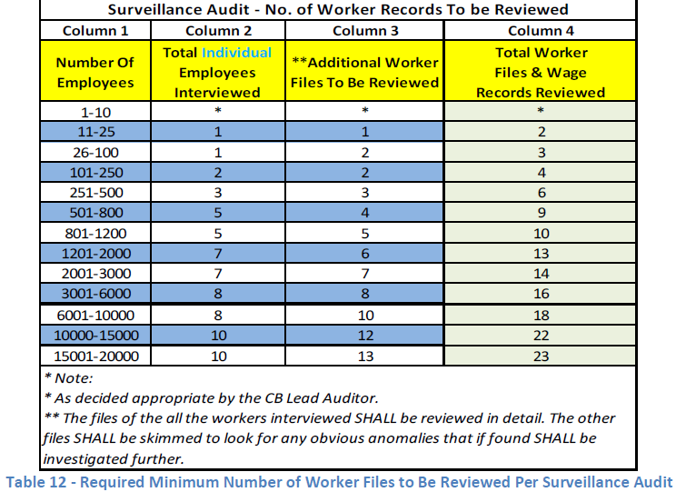

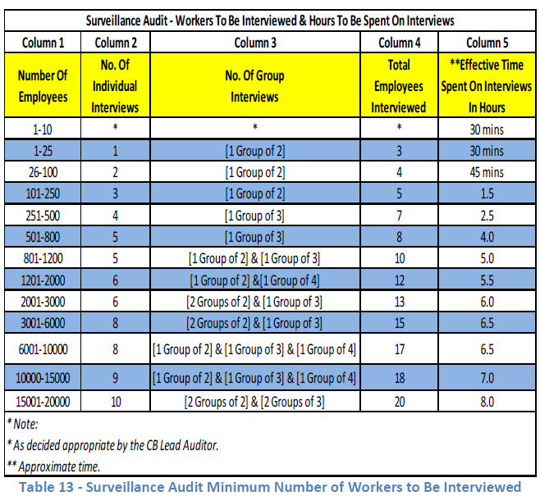

Changes to the scheduling above could be managed taking into account both Client and Audit Team needs.
Changes to the scheduling above could be managed taking into account both Client and Audit Team needs.
Changes to the scheduling above could be managed taking into account both Client and Audit Team needs.
Changes to the scheduling above could be managed taking into account both Client and Audit Team needs.
Changes to the scheduling above could be managed taking into account both Client and Audit Team needs.

